**DEA&DP Ref. No.: 16/3/1/1/D3/4/0008/13**

NEAS REF.: WCP/EIA/0001146/2013

DEA&DP Case Officer: Shireen Pullen

**Calitzdorp Roads Upgrade  
DR1688 & Dr1699**

Proposed upgrade of the DR1688 and Dr1699, between Calitzdorp and oudtshoorn, Western Cape Province

**Compliance AUDIT REPORT  
In accordance with regulations 34(1) of the 2014 EIA regulations (as amended)**

(This audit report aims to conform to the requirements of the NEMA EIA regulations 2014 (as amended), GN 326, 7 April 2017, Appendix 7)

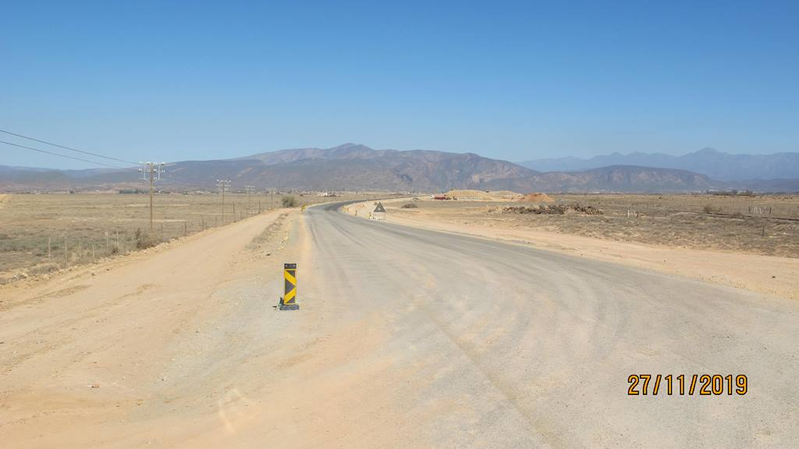

**DATE: 30 November 2019**

**P.J.J. Botes (Pr.Sci.Nat: 400184/05)**

*Registered Professional Botanical, Environmental and Ecological Scientist*

EXECUTIVE SUMMARY

Notice of intent for this project was given on the 15th of January 2019.

**ENVIRONMENTAL AUTHORIZATION(S):** The original Environmental Authorization was granted in terms of the National Environmental Management Act, 1998 (Act. 107 of 1998) and the Environmental Impact Assessment Regulations (2010). Environmental authorization and exemption was granted for the preferred alternative as described in the Final Basic Assessment Report (BAR), dated 13 June 2014.

* DEA&DP Ref. no.: 16/3/1/1/D3/4/0008/13
* Date of issue: 2014/10/13

**COMPLIANCE TO CONDITIONS OF THE EA:** Please refer to Table 2 which gives a summary of the conditions applicable to this environmental authorization and discuss compliance on the hand of evidence obtained. No major non-compliance in terms of the Conditions of the Environmental Authorization were observed or reported.

Paragraph 4.1 gives a summary of outstanding or on-going conditions of the EA that must still be implemented or must still be monitored as part of the future construction activities.

* Environmental control during the construction phases;
* On-going waste management during construction;
* Management of the construction footprint in terms of remaining natural veld;
* Erosion control during rehabilitation;
* Administrative and non-compliance conditions of the ROD/EA.

**COMPLIANCE WITH THE EMP:** Chapter 5 discuss compliance with the EMP and also evaluates the EMP in terms of effectiveness. ECO noted a number of findings throughout the project; however, these were addressed to the satisfaction of the ECO.

This audit report could not identify any significant non-compliance to the requirements of the environmental management programme apart from the following:

* The one aspect that must improve during further construction phases is the management of the construction footprint (Refer to Paragraph 4.1.2), especially with regards to the protection of the remaining seed store (how insignificant it may be) and the protected of remaining natural veld where applicable.

This audit report could also not identify any significant shortcoming or any need for changes to the EMP, or the management and mitigating measures provided for apart from that discussed above.

**CLOSURE PLAN:** Not yet applicable – Construction still in progress.

Lastly: the auditor would like to complement the construction team and the ECO for a well-managed site. On the day of the site visit the site the site gave the impression of an exceptionally well managed and organised site. Stockpiling and waste management seems to be especially well managed. For this the ECO and the contractor should be commended.

Independence & conditions

PB Consult is an independent entity with no interest in the activity other than fair remuneration for services rendered. Remunerations for services are not linked to approval by decision making authorities and PB Consult have no interest in secondary or downstream development as a result of these services. There are no circumstances that compromise the objectivity of this report. The findings, results, observations and recommendations given in this report are based on the author’s best scientific and professional knowledge and available information. PB Consult reserve the right to modify aspects of this report, including the recommendations if new information become available which may have a significant impact on the findings of this report.

Relevant qualifications & Experience of the author

Mr. Peet Botes holds a BSc. (Hons.) degree in Plant Ecology from the University of Stellenbosch (Nature Conservation III & IV as extra subjects). Since qualifying with his degree, he had worked for more than 20 years in the environmental management field, first (1997) at the Overberg Test Range (a Division of Denel) managing the environmental department of OTR and being responsible for developing and implementing an ISO14001 environmental management system, ensuring environmental compliance, performing environmental risk assessments with regards to missile tests and planning the management of the 26 000 ha of natural veld, working closely with CapeNature (De Hoop Nature Reserve).

In 2005 he joined Enviroscientific, an independent environmental consultancy specializing in wastewater management, botanical and biodiversity assessments, developing environmental management plans and strategies, environmental control work as well as doing environmental compliance audits and was also responsible for helping develop the biodiversity part of the Farming for the Future audit system implemented by Woolworths. During his time with Enviroscientific he performed more than 400 biodiversity en environmental legal compliance audits.

During 2010 he joined EnviroAfrica in order to move back to the biodiversity aspects of environmental management. Experience with EnviroAfrica includes NEMA EIA applications, environmental management plans for various industries, environmental compliance audits, environmental control work as well as more than 90 biodiversity & botanical specialist studies.

Towards the end of 2017, Mr Botes started his own small environmental consulting business focusing on biodiversity & botanical assessments, biodiversity management plans and environmental compliance audits.

Mr. Botes is a registered Professional Botanical, Environmental and Ecological Scientists at SACNASP (South African Council for Natural Scientific Professions) as required in terms of Section 18(1)(a) of the Natural Scientific Professions Act, 2003, since 2005.

Declaration of independence

**THE INDEPENDENT PERSON WHO COMPILED THE COMPLIANCE AUDIT REPORT**

I Petrus, Jacobus, Johannes Botes, as the appointed independent specialist hereby declare that I:

* act/ed as the independent specialist in this application;
* regard the information contained in this report as it relates to my specialist input/study to be true and correct, and
* do not have and will not have any financial interest in the undertaking of the activity, other than remuneration for work performed in terms of the NEMA, the Environmental Impact Assessment Regulations, 2014, as amended, and any specific environmental management Act;
* have and will not have no vested interest in the proposed activity proceeding;
* have disclosed, to the applicant, EAP and competent authority, any material information that have or may have the potential to influence the decision of the competent authority or the objectivity of any report, plan or document required in terms of the NEMA, the Environmental Impact Assessment Regulations, 2014 and any specific environmental management Act;
* am fully aware of and meet the responsibilities in terms of NEMA, the Environmental Impact Assessment Regulations, 2014 (specifically in terms of regulation 13 of GN No. R. 326) and any specific environmental management Act, and that failure to comply with these requirements may constitute and result in disqualification;
* have ensured that information containing all relevant facts in respect of the specialist input/study was distributed or made available to interested and affected parties and the public and that participation by interested and affected parties was facilitated in such a manner that all interested and affected parties were provided with a reasonable opportunity to participate and to provide comments on the specialist input/study;
* have ensured that the comments of all interested and affected parties on the specialist input/study were considered, recorded and submitted to the competent authority in respect of the application;
* have ensured that the names of all interested and affected parties that participated in terms of the specialist input/study were recorded in the register of interested and affected parties who participated in the public participation process;
* have provided the competent authority with access to all information at my disposal regarding the application, whether such information is favourable to the applicant or not; and
* am aware that a false declaration is an offence in terms of regulation 13 of GN No. R. 326.

**Note:** The terms of reference must be attached.



Signature of the specialist:

PB Consult (Sole Proprietor)

Name of company:

30 November 2019

Date

TABLE OF CONTENTS

EXECUTIVE SUMMARY ii

Independence & conditions iii

Relevant qualifications & Experience of the author iii

Declaration of independence iv

1. Introduction 7

1.1 Environmental audit 7

1.1.1 Scope of the audit 7

1.1.2 Objectives of the audit 7

1.2 Project description 8

1.2.1 Upgrading of DR1688 8

1.2.2 Upgrading of DR1699 8

1.2.3 Bridges 8

1.2.4 Culverts 9

1.3 Project progress (short summary) 9

2. Abbreviations 11

3. Methodology adopted for preparing the audit report 11

4. Compliance with the conditions of the various environmental authorizations 12

4.1 Outstanding or ongoing conditions of the ROD 17

4.1.1 On-going Environmental control 17

4.1.2 Erosion prevention measures 17

4.1.3 Non-compliance 17

5. Compliance with the EMP’r 18

5.1 Implementation of the EMS documentation 18

5.1.1 Environmental documentation 18

5.1.2 Environmental incident & complaints Registers 18

5.2 Management of land 18

5.2.1 Vegetation clearing 18

5.2.2 Access roads 19

5.2.3 Fires 19

5.3 Waste management 19

5.4 Hazardous chemical substances 19

5.5 Spill response and pollution prevention 19

5.6 Sewage and sanitation 20

5.7 Management, handling and stockpiling of topsoil 20

5.8 Management of watercourses / water sources 20

5.9 Protection of natural & heritage resources 20

5.10 Environmental training & awareness 21

5.11 Licences and permits 21

5.12 Effectiveness of the EMP 21

5.12.1 Potential shortcomings of the EMP 22

5.13 Conclusion 22

6. Closure Plan 22

7. Site photographs 23

**TABLES**

Table 1: Chronological order of events in terms of the EA approval and commnencement process 9

Table 2: a short summary of the Conditions of the EA and notes on compliance with these conditions 13

**APPENDICES**

Appendix 1: Environmental Authorization (13/10/2014)

Appendix 2: Notice of intent to commence (15/01/2019)

Appendix 3: Proof of notification of I&AP’s (outcome of the EA)

Appendix 4: Botanical study – Bergwind botanical surveys and tours

Appendix 5: DEA&DP approval of the updated EMP (Dated 13/07/2015)

Appendix 6: Proof of compliance with other statutory requirements

Appendix 7: An example of the ECO reports

# Introduction

The Western Cape Department of Transport & Public Works applied for environmental authorization to rehabilitate and surface the Divisional Road 1688 (Old Concrete Road) and surface Divisional Road 1699 (Station Road) near Calitzdorp.

Divisional Road 1688 start at the intersection with Trunk Road 31/6 in Calitzdorp and continues for 43.07 km in a South Easterly direction toward Oudtshoorn where it again ties in with Trunk Road 31/6, better known as Route 62. The DR 1688 is a level 4, tertiary residential access collector and it serves various access roads, farms, as well as the well-known Calitzdorp Spa. The road is approximately 60 years old and is one of the first concrete roads constructed in South Africa. The total length of DR1688 is 43.07km. Due to the age and current conditions of the road it was identified as a rehabilitation project. The area investigated for rehabilitation start on the outskirts of Calitzdorp at km 1.07 and continues to the intersection with Trunk Road 31/6 at km 43.07.

Divisional Road 1699 start at the intersection with Divisional Road 1688 and continues for 1.20km to where it intersects with Divisional Road 1661 near the Calitzdorp Station. It will be upgraded from a gravel road to a surfaced standard road.

## Environmental audit

The purpose of this environmental audit is to review compliance to the conditions of the Environmental Authorization (EA) and the Environmental Management Plan (EMP) as well as any other permits, complaints, non-compliances and the ECO reports. The audit report aims to conforms to requirements of the NEMA EIA regulations 2014 (as amended), GN 326, 7 April 2017, Appendix 7, for Environmental Audit Reports.

EnviroAfrica was commissioned to undertake the compliance audit. EnviroAfrica appointed PB Consult to perform the compliance audit. The environmental audit report will be submitted to the DEA&DP for comments and all interested and affected parties will be notified of the submission of the report.

### Scope of the audit

The scope of the audit only includes the rehabilitation of divisional road 1688, from Calitzdorp (kilometer 1.00) to the Calitzdorp Spa turnoff at kilometer 15.64. Contract C1008.01

### Objectives of the audit

The objective of the environmental audit report (in terms of GN 326, 7 April 2017) is to:

* Report on:
  1. The level of compliance with the conditions of the environmental authorization and the EMP’r, and where applicable, the closure plan; and
  2. The extent to which the avoidance, management and mitigation measures provided for in the EMP’r, and where applicable the closure plan, achieve the objective and outcomes of the EMP’r, and closure plan.
* Identify and assess any new impacts and risks as a result of undertaking the activity;
* Evaluate the effectiveness of the EMP’r, and where applicable the closure plan;
* Identify shortcomings in the EMP’r, and where applicable the closure plan; and
* Identify the need for any changes to the avoidance, management and mitigation measures provided for in the EMP’r, and where applicable, the closure plan.

## Project description

According to the BAR, the DR 1688 will be rehabilitated and minor adjustments will be made to the alignment to provide a roadway with an 80km/h design speed where economically feasible. The existing compacted and degraded road verges/shoulders are large enough for the proposed upgrade and widening without entering the adjacent areas containing some natural vegetation. The upgrade and widening activities of DR1688 will remain within the existing compacted road verges/shoulders. No significant vegetation will be impacted upon.

### Upgrading of DR1688

* Section 1 of DR1688 from km 1.07 to km 4.68 will be rehabilitated to a Class 3 road with 2 x 3.4m surfaced lanes, 2 x 0.9m surfaced shoulders and 2 x 0,6m gravel shoulder. Existing degraded culverts will be widened to tie in with the new cross section. **It is important to note that** approximately 2.5m wide, compacted gravel shoulders already exists on both sides of the road. These compacted gravel shoulders are graded on a yearly basis as part of the maintenance procedure of the District Roads Engineer. Widening will therefore take place within this already disturbed and compacted shoulder.
* Section 2 of DR1688 from km 4.68 to km 15.18 will be rehabilitated to a Class 4 road with 2 x 3.4m surfaced lanes and 2 x 0.9m gravel shoulders.
* Section 3 of DR1688 from km 15.18 to km 43.07 will be rehabilitated to a Class 4 road with 2 x 3.4m surfaced lanes and 2x 0.9 gravel shoulders.
* The roads will have:
  + A Minimum design speed of 80km/h
  + 100km/h Maximum speed signage.

### Upgrading of DR1699

According to the BAR, the DR 1699 will be upgraded, but very little changes will be made to the alignment and a design speed of 50km/h will be used. The existing compacted road verges/shoulders is large enough for the proposed upgrade without entering the adjacent areas which contain natural vegetation. The upgrade and widening activities of DR1699 will remain within the existing compacted/degraded road verges/shoulders.

* DR 1699 from km 0.00 to km 1.20 will be upgrade to a Class 4 road with 2 x 3,1m surfaced lanes and 2 x 0.9m gravel shoulders
  + A Minimum design speed of 50km/h
  + 60km/h Maximum speed signage.

### Bridges

These four bridges are all in a fair condition and they only require localised repairs and maintenance. A noted concern is the width of the bridges which varies between 6.0m and 5.4m wide. Although it poses a safety concern it is felt the widening of the bridges in not critical due to the nature of, and the limited traffic on the road. However, the widening of the roadway will necessitate the erection of warning signs on all approaches, to inform travellers of the narrow crossings

The following four bridges are situated along DR1688:

| **Km** | **Description and Size** | **River Road** | **Width** |
| --- | --- | --- | --- |
| 14.83 | B0474-2X9.6mx2.4m | Breelaagte River | 6.0m |
| 19.53 | B0473-9.8mx2.4m | Dongaskloof River | 6.0m |
| 25.73 | B1730 2x13.0mx2.4m | Vlei River | 5.4m |
| 38.85 | B1731 3x6.8m | Wynands River | 5.4m |

### Culverts

According to the BAR, the majority of these culvers is in a poor condition and has been modified over the years. They therefore do not comply with the Department Transport and Public Works’ (DTPW) minimum standards and some are even being used as service ducts. It is therefore proposed that all the relevant culverts be repaired and if necessary upgrade to comply with the DTPW’s minimum standards. It is envisaged that the culvers that are extended with Armco sheeting be repaired with concrete extensions.

The following 23 large culverts exceeding 1.0m in size are situated along DR1688

| **Km** | **Description & Size** | **Km** | **Description & Size** | **Km** | **Description & Size** |
| --- | --- | --- | --- | --- | --- |
| **2.95** | 4/1.20m PC | **23.98** | 2.40m BC AR | **32.41** | 2/2.50m BC |
| **3.64** | 2/1.8m BC | **27.2** | C11065 3.1m BC | **38.54** | 2.1m BC |
| **5.48** | C11067 2/4.6m BC CW | **27.23** | 1.0m BC | **38.71** | 1.80m BC |
| **14.81** | C11066 4.6m BC | **28.57** | 2.70m AR + 2.40m BC | **39.19** | 1.5m BC |
| **17.9** | 2/2.50m BC | **29.62** | 1.20m AR | **39.63** | C11064 2.5m BC |
| **20.6** | 2.40m BC | **29.76** | 2/2.70m BC | **40.2** | 1.00m BC |
| **21.52** | 2.40m BC | **30.01** | 1.5m BC | **41.92** | 1.00m BC |
| **22.9** | 2/1.90m BC | **31.02** | 1.25m BC |  |  |

## Project progress (short summary)

Table 1 gives a short summary of chronological order of events regarding the commencement of construction and progress.

Table : Chronological order of events in terms of the EA approval and commnencement process

| **DATE** | **DESCRIBTION OF EVENT** | **NOTES** |
| --- | --- | --- |
| 2014/10/13 | The original Environmental Authorization was granted in terms of the National Environmental Management Act, 1998 (Act. 107 of 1998) and the Environmental Impact Assessment Regulations (2010). Environmental authorization and exemption was granted for the preferred alternative as described in the Final Basic Assessment Report (BAR), dated 13 June 2014.   * DEA&DP Ref. no.: 16/3/1/1/D3/4/0008/13 * Date of issue: 2014/10/13 | EA and exemption **GRANTED**.  Refer to Appendix 1 for a copy of the EA. |
| 2019/01/15 | Notice of intent to Develop submitted to DEA&DP | Refer to Appendix 2 |
| 2019/11/27 | Construction on both the DR168 and DR1699 still in progress |  |

Figure : An overview of the DR 1699, showing the first section of the road in progress

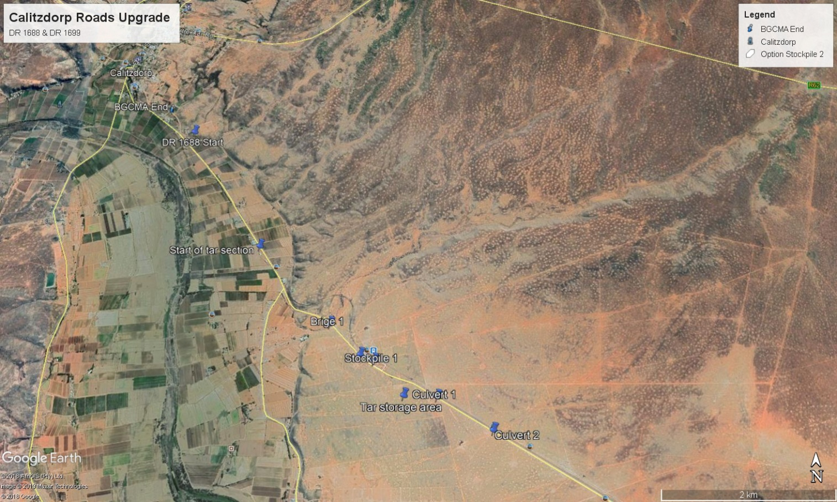

Figure : An overview of the DR 1699, showing the second section of the road in progress (15km mark)

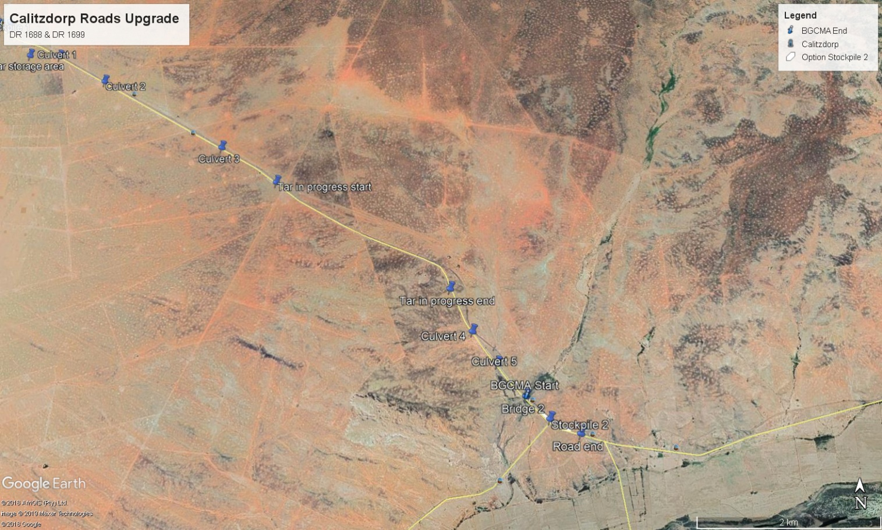

# Abbreviations

|  |  |
| --- | --- |
| CARA | Conservation of Agricultural Resources Act, 1983 (Act no. 43 of 1983) |
| BGCMA | Breede-Gouritz Catchment Management Agency |
| DEA | Department of Environmental Affairs |
| DEA&DP | Department of Environmental Affairs & Development Planning |
| EA | Environmental Authorization (Record Of Decision) |
| EAP | Environmental assessment practitioner |
| ECO | Environmental Control Officer |
| EIA | Environmental impact assessment |
| EMP | Environmental Management Plan or Program |
| EMS | Environmental management system |
| HOA | Home owners association |
| MSDS | Material Safety Data Sheet(s) |
| NEMA | National Environmental Management Act, 1998 (Act no. 107 of 1998) |
| NWA | National Water Act, Act 36 of 1998 |
| ROD | Record of decision |
| SAHRA | South African Heritage Resources Agency |

# Methodology adopted for preparing the audit report

Information on the background and technical aspects of the project was obtained from the Environmental Control Officer and the Consulting Engineers.

A site visit was conducted together with the applicant and EnviroAfrica on the 27th of November 2019.

Further information was gained from evaluating relevant documentation such as:

* The Environmental authorization (DEA&DP Ref. 16/3/1/1/D3/4/0008/13), dated 13 October 2014 (Appendix 1);
* The Basic Assessment Report by Guillaume Nell Environmental Consultants CC;
* The EMP approved by DEA&DP;
* The aquatics assessment by Dr. William R Harding (Report 631/2013);
* The botanical assessment by Bergwind botanical surveys & tours (17 September 2014);
* The notice of intent to commence (Dated 15 January 2019);
* The ECO files;
* Other documentation relevant to the proposed development.

In this environmental audit, compliance with the conditions of the ROD is discussed under Heading 4, while compliance with the EMP is discussed under Heading 5.

# Compliance with the conditions of the various environmental authorizations

Table 2 gives a summary of the conditions applicable to this environmental authorization and discuss compliance on the hand of evidence obtained.

Table : a short summary of the Conditions of the EA and notes on compliance with these conditions

| **No.** | **SHORT DESCRIPTION OF EACH CONDITION** | **COMMENTS ON COMPLIANCE & RECOMMENDATION(S)** |
| --- | --- | --- |
| **E1** | The EA is valid for 5 years from the date of issue. | **Compliant**  **EA Date of Issue:** 13-10-2014 (Valid till 13/10/2019)  **Notification of intent to commence:** 15/01/2019 (Appendix 2) |
| **E2** | The activity may not commence within 20 days of the date of issue (appeal period). | **Compliant**  Refer to comments above |
| **E3** | The applicant must notify all registered I&AP’s within 12 calendar days of the outcome of the application and their right to appeal. | **Compliant**  Refer to Appendix 3 for proof of notifications to registered I&AP’s. |
| **E4** | Seven calendar days’ notice of intent to commence must be given with proof of conditions 2, 11 & 16. | **Compliant**  Please refer to the comments under E1, above and to Appendix 2 for proof of compliance. |
| **E5** | The EA is only applicable to the preferred alternative, as described in Section B of the EA. | **Compliant**  Rehabilitation of the R1699 is in progress, converting the old gravel road in a tar road (as described within the EA).  Rehabilitation of the R1688 is in progress. All works centred on the rehabilitation of the first 15.64km section from Calitzdorp to the Calitzdorp Spa turn-off. The construction works conforms to the description as given in the EA. |
| **E6** | A botanist must be appointed to conduct a botanical survey and search & rescue during the spring season. The report must establish whether there are any plants of significant conservation value. | **Compliant/Partially compliant**  A botanist study was commissioned with recommendations. Refer to Appendix 4.  The report had the following main findings and recommendations:   * Historically the road reserve for both roads had been heavily impacted under the banner of “maintenance”; * The led to a long term negative effect with little truly natural vegetation persisting in the road reserves; * Elements of natural vegetation remained, but in general the road verges have been scraped and compacted; * This resulted in in an extremely disturbed condition with extremely low botanical sensitivity close to the road edges; * However, further away (still within the road reserve), varying levels of disturbance were found (in some places the vegetation was intact, while in other very disturbed); * The overall condition of the vegetation within the road reserves, especially for this phase, are poor, transformed and of low botanical sensitivity, with no meaningful contribution to the conservation of the various vegetation- or ecosystem types; * However, the most important mitigation measure would be to avoid causing any further disturbance of the vegetation within the road reserve, especially the vegetation in the zone between the road verge (which will be compacted) and the boundary fence; * Where disturbance is unavoidable, it should be rehabilitated (treated) to enhance regeneration of the roadside vegetation (e.g. collecting seeds and distributing it back onto the road sections outside of the road verge).   **Findings**:   * The first 15.64 km of the road mostly traversed areas of low botanical sensitivity, when referring to the botanical report, and the slightly better preserved sites does not fall within the sensitive Muscadel Riviere vegetation type; * For safety reasons, temporary by-pass roads had to be constructed next to existing roads, while the concrete from the original roads were recovered and the roads prepared for its new surface (tar). Because of the limited space within the road reserve, it meant that the construction footprint could not be contained within the road verge itself, but in many cases had to utilise almost the whole width of the road reserve (from fence to fence), which meant that the impact on natural vegetation was slightly larger than expected; * However, according to the ECO, the topsoil (with its seed-store) were stripped (and are stored) in areas with remaining indigenous vegetation in order to facilitate later rehabilitation and to mitigate the impact. It was noted that the ECO is also a qualified botanist.   **Recommendations**:   * It is acknowledged that this section of the road was disturbed and of little botanical sensitivity and that the impact is probably low; * It is also acknowledged that having to facilitate traffic during construction has made the disturbance unavoidable; * However, in more sensitive areas it is proposed that road diversions should only impact on one side of the road (choosing the better preserved side for protection), while protecting the other side. Even in these areas, topsoil conservation should be practiced and replaced onto the disturbed road verge once construction has been completed. |
| **E7** | Upon completion of the gravel mining and the re-instatement of the topsoil, seeds of locally indigenous pioneer grass species must be sown in order to reduce erosion and control later temporary invasion of annual alien weed species. | **Noted (future action)**  Construction is still in progress on all the culverts and bridges. Topsoil conservation and re-distribution would also aide this process.  Also refer to Condition E18 of this EA and Paragraph 4.1.2, underneath.  The ECO to monitor these conditions and recommendations made under Paragraph 4.1.2. |
| **E8** | The holder is responsible for ensuring compliance with the conditions contained in the Record of Decision by any person acting on his behalf. | **Compliant (On-going)**  No significant non-compliances was observed during the site visit or reported by the ECO.  The ECO to monitor on-going compliance. |
| **E9** | Any changes to, or deviations from the scope of the description set out in Condition E5 and Section B of the EA, must be approved by the competent authority, before such changes or deviations may be implemented. | **Compliant (On-going)**  No changes or deviations were observed or reported by the ECO.  The ECO to monitor on-going compliance. |
| **E10** | The applicant must notify the competent authority in writing, within 24 hours thereof if any condition is not complied with. | **Compliant (On-going)**  According to the ECO no significant incidents of non-compliance had occur to date.  The ECO to monitor on-going compliance. |
| **E11** | The final EMP must be amended and re-submitted for approval by the DEA&DP. | **Compliant**  Refer Appendix 5, for proof of approval of the updated EMP. |
| **E12** | A copy of the EA and EMP must be kept at the construction site and available to any authorised official representing the competent authority. | **Compliant**  A copy of the EA and EMP were available at the site offices, however, ECO noted in the first audit report that copies of the EA and EMP were not on file. Corrections were made immediately. |
| **E13** | Should any detail of the EA have to be amended, the holder must submit an originally signed notification to the competent authority, detailing the amendment and must receive written confirmation from the competent authority permitting such changes. | **Not applicable**  No changes at present.  Please note that ECO did mention that they might propose an amendment to the EMP for the next construction period.  The ECO to monitor and advice on any amendments needed (with approval from the CA). |
| **E14** | Non-compliance with a condition of the EA or EMP may result in suspension of this EA and may render the holder liable for criminal prosecution. | **Noted**  To be monitored by the ECO |
| **E15** | Notwithstanding this EA, the holder must comply with any other statutory requirements that may be applicable. | **Compliant**  Refer to Appendix 6 for proof of compliance with:   * Landowners approval to pluck protected and unprotected flora (read in conjunction with the CapeNature permit); * CapeNature – permit to pluck protected and unprotected flora (expiry date: 1/03/2020); * BGCMA – Water use authorization in terms of the NWA. |
| **E16** | The applicant must appoint a suitably experienced Environment Control Officer before commencement of any land clearing or construction activities. | **Compliant**  Enviro Works was appointed to fulfil the duties of the ECO and performed these duties throughout the construction Phases.  Refer to Appendix 2 (Notice of intent to commence with proof of compliance), which includes proof of compliance to Conditions 16). |
| **E17** | An integrated waste management approach, based on waste minimisation must be employed. | **Seemingly Compliant**  In general the construction site was very neat, tidy and well organised. Waste material seems to be excellently managed.   * The bulk of the waste material would have been the old concrete/cement (the original road surface) and would have amounted to a considerable amount of waste material. To negate the impact of this waste material, the concrete is crushed and re-used in the base material for the new road. * Smaller waste items like cement bags and wrapping material seem to be well contained and managed. * Littering: apart from one or two items, littering was almost non-existent.   The ECO and the construction team should be commended for the neat and tidy construction site and the efforts to control and minimise waste. This seems to be one of the best managed sites visit by the auditor in a long time. |
| **E18** | No surface or ground water may be polluted due to any activities on the site. Applicable requirements with respect to relevant legislation must be met. | **Seemingly compliant**  A water use authorization was obtained from the BGCMA for work needed on culverts and bridges. The present drought that is experienced in this area, also allow for work to be done while there is no water in any of these systems.  However, the construction team (supervised by the ECO) will have to ensure that erosion prevention measures are in place to ensure future protection of the features within water courses. Also refer to Condition E7 of this EA and Paragraph 4.1.2, underneath.  The ECO to monitor these conditions and recommendations made under Paragraph 4.1.2. |
| **E19** | Applicable requirements with respect to relevant legislation pertaining to occupational health and safety must be adhered to. | **Compliant**  The SHE Group has been appointed to monitor Occupational Health & Safety on site.  Monthly reports are available. |
| **E20** | Should any heritage remains be exposed it must be reported to the HWC immediately. | **Compliant**  No heritage remains had been observed or reported by the ECO to date.  The ECO to monitor throughout the project phases. |

## Outstanding or ongoing conditions of the ROD

The following gives a short summary of outstanding or ongoing actions to be implemented (most of which are not yet applicable) as well as recommendations on potential improvement (if applicable).

### On-going Environmental control

The ECO should be commended on what seems to be excellent environmental control of the site (especially regarding waste management and housekeeping on the various construction footprints).

* The ECO must ensure that the recommendations made by the Botanist specialist report are adhered to (Refer to Condition E6 of the EA);
* The ECO must ensure that the erosion control measures as described in Condition E7 are implemented. However, please note the discussion under Paragraph 4.1.2, underneath;
* The ECO must ensure that any changes to or deviations from the scope of the description of the project are approved by the competent authority as described in Condition E9);
* The ECO must monitor potential non-compliance to any condition of the EA or EMP as described in Condition E10, E13, E14 & E15, (e.g. take note that Flora permit expires during March 2020, and will have to be updated);
* The ECO must ensure that an integrated waste management approach is maintained as described under Condition E17;
* The ECO must monitor and ensure that no surface or ground water are polluted due to any construction activities as described under Condition E18;
* The ECO must monitor for any heritage remains throughout the life-span of the project as described under condition E20.

### Erosion prevention measures

Condition E7 of the EA stipulates that seeds of locally indigenous grass species must be collected and sown onto disturbed areas after areas had been re-instated and topsoil had been replaced. The ECO commented that this would be quite a challenge considering the unusual drought currently experienced in the Calitzdorp area. At present there is just no grass or for that fact, almost no indigenous shrub species remaining to harvest any seeds from.

* It is thus recommended that topsoil conservation must be done very diligently (even if it seems as if there are no plants in the specific areas), as the top layer of soils within the road reserve is still very likely to contain a seed store (within the top 10-15 cm of the soils).
* Replacing the topsoil on top of the re-instated areas, would allow at least for some re-seeding.

### Non-compliance

* The holder must notify the competent authority and any other relevant authority, in writing, within 24 hours if any condition of the EA is not adhered to, in accordance with Condition E8, E9, E10, E13, E14 and E15.

# Compliance with the EMP’r

This section deals with compliance to the EMP based on the ECO reports and observations made during the site visit. The ECO checked environmental compliance twice monthly, using an environmental compliance checklist developed by Enviro Works and reporting through a monthly environmental report (Refer to Appendix. The Checklist reported on the following main headings:

* Implementation of the EMS documentation;
* Management of Land;
* Waste Management;
* Hazardous chemical substances;
* Spill response and pollution prevention
* Sewage and sanitation;
* Management, handling and stockpiling of topsoil;
* Management of watercourses / water sources;
* Protection of natural & heritage resources;
* Environmental training & awareness;
* Licences and permits;

## Implementation of the EMS documentation

The ECO checked all EMS documentation on a monthly basis against their own environmental compliance checklist. A DEO (designated environmental officer) was appointed within the construction team, who are responsible to monitor day-to-day environmental compliance and discuss/report issues with the ECO.

### Environmental documentation

* An Environmental Policy was on file and displayed at the site offices;
* A copy of the EA and EMP were on file at the site offices;
* The DEO signed the declaration of understanding;
* Method statements were filed within the environmental file at the site offices;
* Monthly environmental monitoring reports are compiled by the ECO and kept on file.

### Environmental incident & complaints Registers

Both an environmental incident- and a complaints register were on file.

## Management of land

Site Layout plans, which include road works, location and boundaries of stockpile area) were required by the ECO. Construction footprints had to be demarcated, with no works allowed outside the demarcated areas.

### Vegetation clearing

Construction footprint had to be demarcated and no works were allowed outside of the demarcated areas.

* The ECO reported a number of incidents where work was done outside of these footprints. However, it was also clear that to maintain safe environment larger footprints had to be allowed for the by-pass roads.
* Unfortunately the road reserve is relatively narrow, which meant that the impact on vegetation were larger than originally expected.
* Non-the-less, this will have to better address during the future phases especially in areas with remaining vegetation of higher significance.

### Access roads

All temporary access roads (e.g. access to bridges and culverts) outside of the dedicated footprint had to be approved by the ECO before they can be constructed.

* Temporary access roads to culverts and bridges had to be clearly demarcated;
* All temporary access roads, must be re-habilitated on completion of the works at each site;
* Photographic evidence of all rehabilitation measures to be kept on file.

### Fires

No open fires were allowed on site or within the site camp (except in designated areas).

## Waste management

General waste is collected in waste bins that had to be placed at each work site. Collection of waste into bags alone were not allowed, unless for immediate transport. General waste and potential hazard waste was sorted separately.

* Waste bins were to be cleaned on at least a weekly basis;
* Waste safe disposal slips were required and checked by the ECO;

**Compliance**

* Small issues were observed within the ECO files, but no significant non-conformities were recorded;

## Hazardous chemical substances

A register of hazardous substances were required by the EMP. Hazardous waste (with their MSDS) had to be recorded and filed at the site offices.

* Hazardous substances were stored in bunded areas;
* Personnel received induction training, with proof of training on file.

## Spill response and pollution prevention

Spill kits and drip trays were a requirement at the construction site. The DEO and key staff were trained in the usage of the spill kit. The ECO checked spill kits and drip trays on monthly basis.

**Compliance**

* According to the ECO, the DEO had a spill kit permanently in the back of his vehicle.
* No incidents were reported.

## Sewage and sanitation

According to the EMP adequate ablution and washing facilities had to be available at active working areas, but they may not be placed within 100m of any watercourse.

**Compliance**

* According to the ECO reports adequate chemical toilets were placed strategically at each active working area;
* Records of cleaning of these facilities were on file;
* No incidents of spillages were recorded.

## Management, handling and stockpiling of topsoil

According to the EMP, stockpiles may only be placed at dedicated stockpile areas. They must be kept clean of alien invasive weeds. This includes the stockpiling of topsoil, which must be kept separate of other material.

**Compliance**

* A number of small incidents were observed by the ECO and addressed by the contractor;
* No significant non-conformities were recorded.

## Management of watercourses / water sources

According to the EMP, construction material may not be stockpiled on river banks or within any watercourse or floodplain. Spill kits and drip trays must be available and in place when working near any watercourse. No watercourses may be diverted, dammed or modified without a water use license in place. In addition no sediment or run-off may enter the watercourses (control measures must be in place).

**Compliance**

* According to the ECO reports and evidence seen (Refer to Appendix 6) a water use authorization for construction within the watercourses were in place;
* No stream diversions would be required;
* Contracts were in place with adjacent landowners where access means entering their property;
* Agreements were on file for the use of borehole water from neighbouring landowners and records of water abstraction are kept;
* No significant non-conformities were recorded, according to the ECO reports.

## Protection of natural & heritage resources

According to the EMP, key personnel had to be given awareness training regarding heritage and cultural artifacts and finds. A procedure for reporting finds must be on file and staff must be aware of this procedure.

**Compliance**

* According to the ECO report, personnel received induction training on cultural and/ or heritage artifacts and training records were on file;
* Construction footprints had to be clearly demarcated, aiming at minimum disturbance;
* According the ECO reports a number of incidents relating to clearing of areas wider than the original footprint were recorded.
* However, no heritage or cultural finds were observed or reported to date (the chances of any heritage finds was considered very low by the BAR).

## Environmental training & awareness

According to the EMP the ECO are responsible in ensuring everyone on site is given and environmental awareness induction session which not only clearly defines what the environment is and specifics detailing the local environment but outlines the requirements of the EMP as a management tool to protect the environment.

Refresher courses must be conducted as and when required. The EO or ESO must ensure daily toolbox talks include alerting the workforce to particular environmental concerns associated with the tasks for that day or the area/habitat in which they are working. Awareness posters and a hand out must be produced to create awareness throughout the site.

**Compliance**

* According to the records all personnel of the main contractor (Amandla-Umzali JV) received appropriate training on the 10th and 22nd of February 2019.
* Newly appointed personnel underwent the same training and records of all training are kept on file.
* Toolbox talks included environmental compliance issues for each working area and records are on file.

## Licences and permits

The EMP and EA required that the holder must comply with any other statutory requirements that may be applicable to the undertaking of the listed activities.

**Compliance**

* According to the ECO all necessary statutory requirements were in place (Refer to Appendix 6);
* Statutory requirements were reviewed on a monthly basis by the ECO;
* The ECO also evaluated compliance to these authorizations or permits;
* No non-compliances were recorded or observed.

## Effectiveness of the EMP

The EMP is based on the EMP Guideline provided by DEA&DP which was compiled in accordance with the Integrated Environmental Management (IEM) philosophy which aims to achieve a desirable balance between conservation and development (DEAT, 1992). The IEM guidelines intend encouraging a pro-active approach to sourcing, collating and presenting information in a manner that can be interpreted at all levels.

The EMP clearly defined the project and describes the scope of work in some detail and:

* It touches on potential noise pollution, heritage impact and visual impact, which were seen as aspects not likely to result in significant environmental impact;
* It also touches on potential impacts on fauna and flora, but mentioned that a botanical assessment and search and rescue during the spring before construction activities;
* It covers enforcement, monitoring and auditing and communication channels;
* Section 4 describes generic construction phase implementation which is quite descriptive and very detailed. It seems to be a very good tool to use for guiding compliance for almost all potential situations that might arise.
* Although the introduction and site specific section does are not very specific, Section 4 seems to introduce all relevant specialist findings and special measures within the Pre-construction (planning) phase EMP.

### Potential shortcomings of the EMP

According to the evidence seen, the EMP could cope with all the requirements of the construction phases to date. It strength being in the comprehensive covering of almost all construction related activities.

Apart from the recommendations made under heading 4.1.2, no other improvements or updates could be identified that will result in any significant improvement on the management of the construction activities.

## Conclusion

This audit report could not identify any significant non-compliance to the conditions of the environmental authorization(s) or any major non-compliance to the requirements of the environmental management programme.

It could also not identify any significant shortcoming or any need for changes to the EMP, or the management and mitigating measures provided for.

# Closure Plan

Not applicable: construction is still in progress.

# Site photographs

|  |  |
| --- | --- |
|  | Photo 1: Construction progress DR1699 (not applicable to the this audit report, but included to give the full picture of construction progress) |
|  | Photo 2: Construction progress DR1699 (not applicable to this report) |
|  | Photo 3: The DR1688 at the point where upgrades started |
|  | Photo 4: DR1688, construction activities and by-pass road at the first bridge from Calitzdorp direction |
|  | Photo 5: A closer look at the bridge rehabilitation in progress. |
|  | Photo 6: Stockpile area one, next to the DR1688. The cement would be crushed and used as subbase along the road |
|  | Photo 7: Tar mixing area |
|  | Photo 8: A portion of the completed road section |
|  | Photo 9: A portion of the construction area, showing the DR1688 to the left, with the by-pass road next to it. |
|  | Photo 10: The grader re-shaping the road shoulder. In areas like these, topsoil must be removed beforehand and replaced afterwards. |
|  | Photo 11: one of the larger culverts along the DR1688. |
|  | Photo 12: Bridge rehabilitation in progress, with the by-pass road to its left |

Appendix 1: Environmental Authorization (13/10/2014)

Appendix 2: Notice of intent to commence (15/01/2019)

Appendix 3: Proof of notification of I&AP’s (outcome of the EA)

Appendix 4: Botanical study – Bergwind botanical surveys and tours

Appendix 5: DEA&DP approval of the updated EMP (Dated 13/07/2015)

Appendix 6: Proof of compliance with other statutory requirements

Appendix 7: An example of the ECO reports