19 July 2018
Dear Interested and Affected Party
NEMA PUBLIC PARTICIPATION PROCESS
PROPOSED RESORT DEVELOPMENT ON PORTION 18 OF FARM 387, GORDONIA RD, GROBLERSHOOP, !KHEIS LOCAL MUNICIPALITY
Notice is hereby given of the intention to submit an application, and the public participation process in terms of the National Environmental Management Act, 1998 (Act No. 107 of 1998), as amended (“NEMA”), Environmental Impact Assessment Regulations 2014, and the Section 24G Application in terms of the NEMA EIA Regulations 2014. The proposed resort development includes activities listed in terms of the NEMA EIA Regulations 2014. A Water Use Licence Application (WULA) in terms of the National Water Act, 1998 (Act 36 of 1998) may also need to be applied for. EnviroAfrica cc has been appointed by Leon and Carmen Humphreys to undertake the NEMA application for Environmental Authorisation process.
Application for environmental authorisation for the following activities in terms of NEMA EIA Regulations 2014:
Government Notice R327 (Listing Notice 1): Activity No. 12, 19, 27
Government Notice R324 (Listing Notice 3): Activity No. 6, 11, 12, 14
The activities that have been completed or have commenced (Section 24G Application) will constitute the following listed activities in terms of the NEMA EIA Regulations 2014:
Government Notice R327 (Listing Notice 1): Activity No. 12, 19, 27
Government Notice R324 (Listing Notice 3): Activity No. 6, 12, 14
*Please note that the listed activities above may change during the course of the NEMA Application process. Registered I&APs will be notified of any changes.
Project Description & Location:
The site is located on Portion 18 of Farm 387, Gordonia RD, located approximately 1.7km north of Groblershoop. The site access is located on the north-western side of the N8, just after the Orange River bridge. Site access co-ordinates: 28º 52’ 37.13” S, 21º 59’ 24.25” E.
Construction has commenced on the development of a holiday resort. To date, tented units, mobile units and 2-bedroom masonry units (combined total of 27 beds) have been constructed, including a thatched roof entrance, restaurant, ablution facilities, swimming pool and laundry room. Infrastructure including septic tanks have been constructed and access and internal roads have been cleared.
Further infrastructure such as an amphitheatre, solid waste facility and additional accommodation is also proposed. A double story, 16-bed hotel is proposed on the eastern bank of the Orange River, to the north-west of the property. A quarter mile racing strip and spin track with a paved parking area is also proposed on the south-eastern side of the property, with a separate access from the N8.
Public Participation:
Interested and Affected Parties (I&APs) are hereby notified of the application and invited to register (in writing) and/or provide initial comments and identify any issues, concerns or opportunities relating to this project to the contact details provided below, on or before 27 August 2018. In order to register or submit comment, I&APs should refer to the project name, and provide their name, address & contact details (indicating your preferred method of notification) and an indication of any direct business, financial, personal, or other interest which they have in the application. You are also requested to pass this information to any person you feel should be notified. Please note that future correspondence will only be sent to registered I&APs.
Please note that only Registered I&APs:
- will be notified of the availability of reports and other written submissions made (or to be made) to the Department by the applicant, and be entitled to comment on these reports and submissions;
- will be notified of the outcome of the application, the reasons for the decision, and that an appeal may be lodged against a decision; and
- will be notified of the applicant’s intention to appeal the decision of the competent authority
Consultant: EnviroAfrica CC. P.O. Box 5367, Helderberg, 7135 / Fax: 086 512 0154 / Tel: 021 8511616 / E-mail: admin@enviroafrica.co.za

PROPOSED RESORT DEVELOPMENT ON PORTION 18 OF FARM 387, GORDONIA RD, GROBLERSHOOP
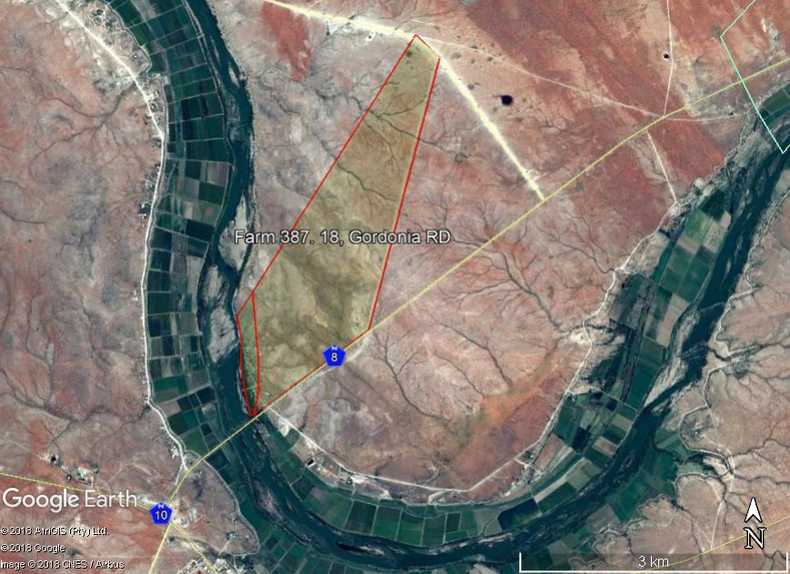  Resort development  Site Entrance  Proposed track  Proposed Hotel  N8  Groblershoop  Orange River  N10  The site  Upington | SITE CO-ORDINATES:  SITE ACCESS  28° 52' 37.13"S  21° 59' 24.25"E  PORTION 18 of FARM 387  Resort Development  Proposed Hotel  Proposed ¼ Mile Strip and Spin Track
ENVIRO AFRICA REF:
0474
JULY 2018

